**ST. XAVIER’S COLLEGE**

**(Affiliated to Tribhuvan University)**

**Maitighar, Kathmandu**



**COMPUTER GRAPHICS**

**LAB ASSIGNMENT #8**

**Submitted by:**

Lokendra puri

013BSCCSIT023

**Submitted to:**

|  |  |
| --- | --- |
| **Er. Anil K. Sah** |  |

Lecturer

Department of Computer Science

Date of submission: 8th September, 2015

STATEMENT: WAP TO ILLUSTRATE REFLECTION.

SOURCE CODE:

//---------------------------------------------------------------------------

#include <vcl\vcl.h>

#pragma hdrstop

#include "Unit1.h"

int x,y,a,b,i,j;

//---------------------------------------------------------------------------

#pragma resource "*.dfm"

TForm1 *Form1;

//---------------------------------------------------------------------------

__fastcall TForm1::TForm1(TComponent* Owner)

: TForm(Owner)

{

}

//---------------------------------------------------------------------------

void __fastcall TForm1::originClick(TObject *Sender)

{

x=Image1->Height;

y=Image1->Width;

for (i=0;i<=x;i++)

{

for (j=0;j<=y;j++)

{

a=-i;

b=-j;

a=a+x;

b=b+y;

Image2->Canvas->Pixels[a][b]=Image1->Canvas->Pixels[i][j];

}

}

}

//---------------------------------------------------------------------------

void __fastcall TForm1::xaxisClick(TObject *Sender)

{

x=Image1->Height;

y=Image1->Width;

for (i=0;i<=x;i++)

{

for (j=0;j<=y;j++)

{

a=i;

b=-j;

b=b+y;

Image3->Canvas->Pixels[a][b]=Image1->Canvas->Pixels[i][j];

}

}

}

//---------------------------------------------------------------------------

void __fastcall TForm1::yaxisClick(TObject *Sender)

{

x=Image1->Height;

y=Image1->Width;

for (i=0;i<=x;i++)

{

for (j=0;j<=y;j++)

{

a=-i;

b=j;

a=a+x;

Image4->Canvas->Pixels[a][b]=Image1->Canvas->Pixels[i][j];

}

}

}

//---------------------------------------------------------------------------

void __fastcall TForm1::yequalsxClick(TObject *Sender)

{

x=Image1->Height;

y=Image1->Width;

for (i=0;i<=x;i++)

{

for (j=0;j<=y;j++)

{

a=j;

b=i;

Image5->Canvas->Pixels[a][b]=Image1->Canvas->Pixels[i][j];

}

}

}

//----------------------------------------

OUTPUT:

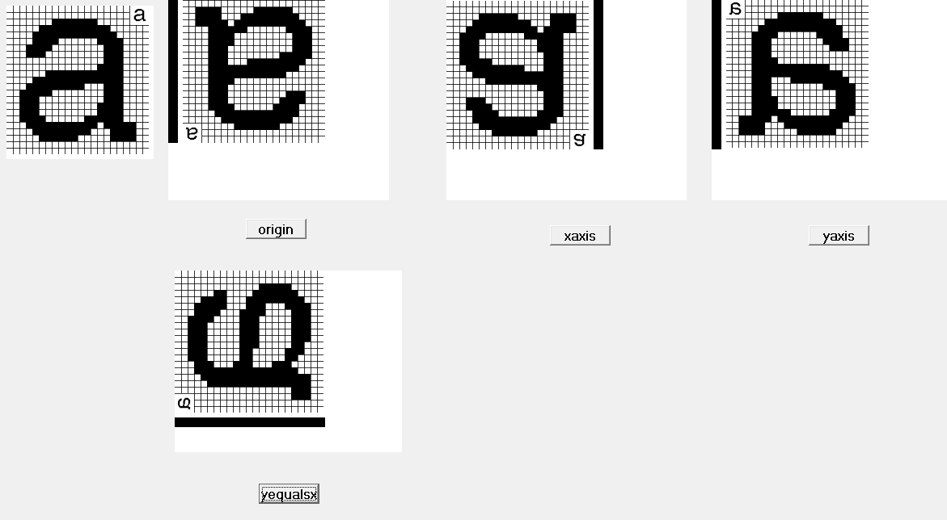

CONCLUSION:

Hence different types of reflection were illustrated using c++ Builder.